Maybank
Customer Engagement Platform (CEP) – CMS
Detailed Design Document (DDD)

Confidentiality Notice
This document contains proprietary information that is confidential to Malayan Banking Berhad (Maybank) and the Next-Gen App (NGA) Initiative. Unauthorized disclosure of this document, whether in full or in part, may result in material damage to Maybank. Written permission must be obtained prior to the disclosure of this document to any third party.
Any printed or photocopied version of this document is considered an uncontrolled copy. The original, approved electronic version is deemed the controlled copy.

TABLE OF CONTENTS
TABLE OF CONTENTS 3
1. Document Purpose & Scope 1
1.1 Document Purpose 1
1.2 Architectural Strategy 1
1.2.1 Contract-Driven Design 1
1.2.2 Global & Country Configuration 2
1.2.3 Architectural Principles 2
1.3 System and Boundaries Included (In-Scope) 2
1.3.1 CMS Platform 2
1.3.2 Content Models and Managed Structures 2
1.3.3 Contract Exposure Layer 3
1.3.4 Content Governance and Lifecycle 3
1.4 Out of Scope Clarifications 3
2. High-Level Architecture View 3
2.1 Component Diagram 3
2.2 Component Descriptions 4
2.2.1 Frontend Delivery Layer 4
2.2.2 CEP Domain 4
2.2.3 Other Domain Integrations 5
2.3 Microservices Listing 5
2.4 Key Design Patterns 6
3. Functional Design 7
3.1 Sequence Diagrams 7
3.1.1 Journey 7
3.1.2 Screen 8
3.1.3 Notification Template 9
3.1.4 Receipt Template 10
3.1.5 Manifest 10
3.1.6 Webhook 11
3.2 Content Configuration 11
3.2.1 Configurable Content Types 11
3.3 Content Lifecycle 12
3.3.1 Change Classification 12
3.4 Versioning Strategy 13
3.5 Locationisation Strategy 13
3.6 Payload Projection 13
3.7 Governance 14
3.7.1 Role-Based Access Control 14
3.7.1.1 Viewer 14
3.7.1.2 Editor 14
3.7.1.3 Reviewer (Publisher) 15
3.7.1.4 Super Admin 15
3.7.2 SOPs 15
3.7.2.1 Base Principles 16
3.7.2.1.1 No Sensitive Data Storage 16
3.7.2.1.2 Clear Ownership Boundaries 16
3.7.2.1.3 Version Control 16
3.7.2.2 Naming Conventions 16
3.7.2.2.1 Content Naming 16
3.7.2.2.2 Content Field Naming 17
3.7.2.2.3 ID Field Values 17
4. API Design 18
4.1 API Principles 18
4.2 API Endpoint & Design Specification 19
5. Data Design 19
5.1 Logical Data Model 19
5.2 Data Flow Diagrams 21
5.2.1 Static Content Data Flow 21
5.2.1.1 L1 21
5.2.1.2 L2 22
5.2.2 Dynamic Content Data Flow 23
5.2.3 Hybrid Content Data Flow 24
5.3 Caching Strategy 25
6. Appendix 25
6.1 Glossary of Terms 25

Revision History
Version | Effective Date | Summary of Changes
1.0.0 | 29/04/26 | Initial Release
1.0.1 | 30/04/26 | Correct minor mistake

Prepared By
Name | Project Role
Daniel Pearson | Senior Consultant
Raihan Al Bazzy | Consultant
Yudhi Hermanwan | Consultant

Stage 1: Reviews the validity and accuracy of the High / Low Level Design
Reviewed By
Name | Department | Project Role | Section | Signature | Date
Dendy Aryaga |  | Delivery Lead

Stage 2: (a) Approves and supports the reviewed scope of work raised for project
(b) Agrees to the proposed changes and enhancements to the system
Approved By
Name | Department | Project Role | Section | Signature | Date

Document Purpose & Scope

Document Purpose
This document defines the principles, responsibilities and detailed technical design required to implement the integration model between the CMS domain, downstream domain services and the NextGen Mobile Application (NGA).
Its purpose is to:
- Establish a shared understanding of system responsibilities
- Define ownership boundaries across CMS, domain services and NGA
- Define the types of content and configuration managed in CMS
- Clarify API contract expectations
- Detail any enhancements required on top of the base CMS system
- Prevent ambiguity in integration patterns
- Serve as a baseline for future enhancements
It provides:
- API specifications, including request/response schemas, versioning and error handling
- Data contracts and payload structures
- Content modelling definitions
- Integration sequence flows and interaction patterns
- Caching behaviour
- Configuration requirements
- Localisation handling strategy
- Content versioning strategy
- Content governance and lifecycle
The level of detail provided is sufficient for engineering teams to implement the solution without architectural ambiguity.

Architectural Strategy
The architecture is built around contract-driven integration, where CMS acts as the authoritative source for structured content consumed by multiple systems.

Contract-Driven Design
- CMS exposes content and configuration through defined provider contracts aligned to consuming applications and services.
- Content models are designed from the required output structure and consumer retrieval pattern first.
- Contracts are shaped to be consumer friendly, stable and implementation ready.
- CMS owns the structure and publication of contracts while consuming systems own how they interpret and execute them.

Global & Country Configuration
- CMS supports the separation of globally reusable content from country specific configuration.
- Global definitions are created once and reused where no market level variation is required.
- Country specific content is managed as an explicit variation layer, not as ad hoc duplication.
- Localisation and market differences are controlled through governed configuration structures.
- The contract delivered to consumers must resolve to the correct market specific version for the requested context.

Architectural Principles
- CMS is the single source of truth for presentation-oriented content and non-executable configuration metadata.
- Execution logic remains in domain services.
- No runtime decision logic is executed in CMS.
- Each contract type is versioned independently.
- Contracts are strictly typed and schema defined.

System and Boundaries Included (In-Scope)
The CMS domain is responsible for the following capabilities:

CMS Platform
Headless CMS capabilities including content modelling, content storage, administrative interfaces, API exposure, role-based access control and lifecycle management for managed content.
Additionally, the storage and retrieval of structured content, metadata, localisation variants and versioned records required for downstream consumption.

Content Models and Managed Structures
Content structures used to define screen-level content and component-level content for frontend or downstream screen rendering use cases.
Structured notification templates managed in CMS and exposed for downstream consumption by the MBPNS notification service.
Reusable content entities such as labels, messages, help text, banners, media references and other common content elements intended for reuse across multiple content records.
Localisation of text content for use in respective markets.

Contract Exposure Layer
CMS owned APIs that expose consumer optimised payloads for downstream systems based on approved content structures and retrieval patterns.
Content projection logic which handles content manipulation logic required to assemble CMS managed records into stable contract responses expected by consuming applications and services.

Content Governance and Lifecycle
Content workflow management lifecycle including draft, review, approval and publish lifecycle states for content before release to consuming systems.
Mechanisms and rules for maintaining versioned content, assessing backward compatibility and supporting controlled contract evolution.

Out of Scope Clarifications
Frontend / Channel Applications: The design and implementation of consuming frontend channels, including NGA MFE, mobile applications and web portals are out of scope. These channels consume CMS exposed content contracts but are not part of the CMS component design.
Downstream Domain Logic: The internal logic of downstream systems such as STP, MBPNS and other domain services is out of scope. These systems are treated as consuming dependencies that retrieve and process CMS managed content according to their own domain rules.
Business Process Orchestration: Runtime journey execution, transaction processing, decisioning logic and backend orchestration behaviour are out of scope. The CMS is responsible for storing and exposing configured content and structured definitions but not for executing business flows.

High-Level Architecture View

Component Diagram
The NGA Mobile App consumes CMS-managed content through Akamai CDN, which provides the frontend delivery path for cached and secured content access. All frontend requests to Strapi CMS are routed through Akamai.
Strapi CMS is hosted within the CEP domain and acts as the central provider for journey, screen, modal and re-usable template content. CMS content is persisted in the CMS MySQL database and exposed through structured APIs.
Within the CEP domain, STP retrieves STP screen content from Strapi CMS. MBPNS retrieves notification templates and related content for customer communications.
P&T and ECLIPSE integrate with Strapi CMS through internal service-to-service API calls. These backend integrations do not route through Akamai.
For content consumed by other domains, content is required to be cached into Hazelcast by the respective domains. Strapi CMS will provide a webhook to notify respective domain of content updates.
This design separates frontend content delivery from backend service integration. Strapi CMS remains the content provider, while orchestration, runtime execution and business logic remain owned by the respective consuming systems.
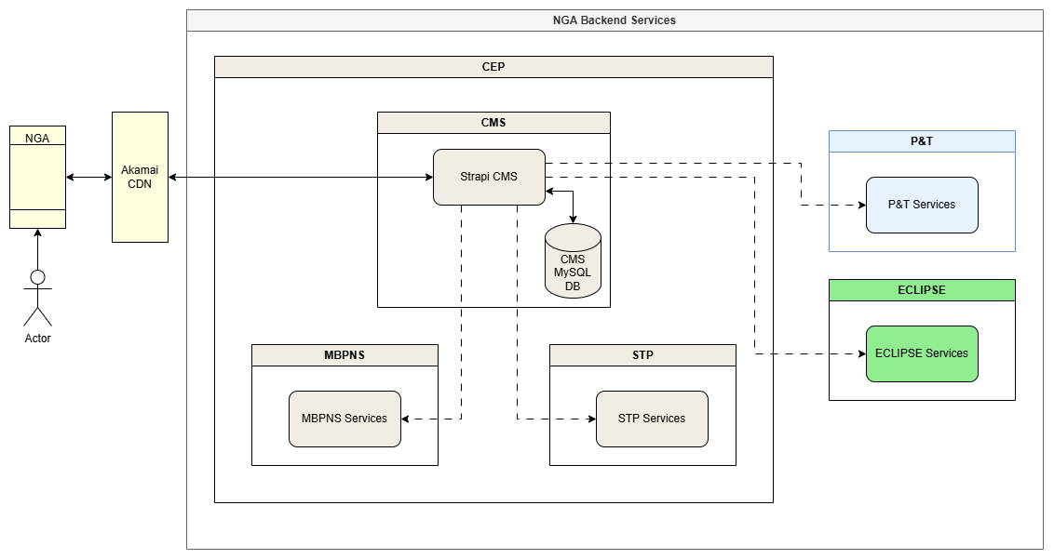

Component Descriptions

Frontend Delivery Layer
Defines the controlled frontend access path for NGA Mobile to retrieve CMS-managed content.
NGA Mobile App
The NGA Mobile App is the frontend client that consumes CMS-managed content for journeys, screens and related UI content. It does not call Strapi CMS directly.
Akamai CDN
Akamai CDN provides the public delivery path between NGA Mobile and Strapi CMS. It handles frontend traffic routing, caching and secured content delivery before forwarding valid requests to Strapi CMS.

CEP Domain
Defines the internal domain boundary where Strapi CMS, STP and MBPNS are hosted.

Strapi CMS
Strapi CMS is hosted within the CEP domain and acts as the central provider for CMS-managed content. It exposes structured APIs for journey content, screen content, modal content, notification templates and configuration content.
Strapi CMS provides content only. It does not execute journeys, perform orchestration, process transactions or own business logic.
CMS MySQL Database
The CMS MySQL database stores Strapi CMS content, metadata, relationships, versions and publishing state. Strapi CMS is the only component that can directly accesses this database.
STP Services
STP Services integrate with Strapi CMS to retrieve screen content required for STP-driven flows. Runtime journey execution and business processing remain owned by STP.
MBPNS Services
MBPNS Services integrate with Strapi CMS to retrieve notification templates and related content used for customer communications. Notification delivery and runtime notification processing remain owned by MBPNS.

Other Domain Integrations
Defines backend domains that consume CMS-managed content through internal service-to-service integration.
P&T Services
P&T Services integrate with Strapi CMS to retrieve CMS-managed content or configuration required by payment and transfer journeys. These backend integrations do not route through Akamai.
ECLIPSE Services
ECLIPSE Services integrate with Strapi CMS to retrieve CMS-managed content or configuration required by ECLIPSE domain services. These backend integrations do not route through Akamai.

Microservices Listing
Microservices naming convention will be split product-wise, top-down and suffixed by region.
CEP associated microservices follow the naming pattern:
cep-<category>-<country_code>
Where:
- <category> = Functional domain of the microservice
- <country_code> = Supported country codes (id, sg, my, ph, kh)
CEP
Category | Name | Remark
CMS | cep-cms-<country_code> | Provides static content

Key Design Patterns
Centralise business-managed content: Strapi CMS is the authoritative source for structured content such as labels, banners, screen content, modal content, notification templates and configuration metadata.
Decouple content from code: content changes should be managed independently from mobile app releases or backend deployments, reducing dependency on engineering for routine updates.
Enable governed business ownership: business and content teams can manage approved content, while engineering defines the content models, API contracts, validation rules and integration boundaries.
Support content localisation: Strapi CMS should support multiple languages without embedding localisation logic in application services.
Intelligent content configuration patterns: content should be configured in such a way that changes to common language / text used can happen easily and rapidly.
Expose content through structured APIs: content should be consumed through governed, versioned APIs rather than direct database access or unmanaged retrieval patterns.
Separate content from runtime logic: Strapi CMS owns content storage and delivery only. Rendering, orchestration, runtime decisioning, transaction processing and business logic remain with the consuming systems.
Control publishing and versioning: content should follow a managed lifecycle for review, approval, publishing, rollback and auditability.

Functional Design

Sequence Diagrams

Journey


Screen


Notification Template

Receipt Template

Manifest


Webhook

Content Configuration
For a detailed specification of each content configured in Strapi CMS, please refer to CEP_CMS_DDD_Configuration_Design_v1.0.xlsx

Configurable Content Types
Content | Type | Description
Module | Collection Type | A versioned record which is the base content structure for a set of screens and models used in a NGA journey
Screen | Collection Type | A versioned record which the contains all the component content used in a screen – screens have 2 types: static and STP. Largely the 2 screen types are the same apart from some slight structure differences and additional configuration parameters
Components | Component | Components are a collection of servers driven UI elements (SDUI) which can be used in screens or modals for content configuration
Notification Template | Collection Type | A versioned record of a notification template – used by MBPNS
Receipt Template | Collection Type | A versioned record of a receipt template – used by Receipt Library
i18n-keys | Collection Type | A collection of internationalization keys that can be used throughout any content
i18n-content | Collection Type
help-support-setting | Single Type | Stores localised Help & Support screen content: contact numbers, guide link, and about/legal policy URLs. One published record per locale
Security-images | Collection Type | A collection record of security-images filename – used by Identity

help-support-setting is the first Single Type in the CMS content model. Unlike Collection Types, a Single Type holds exactly one record per locale — there is no contentId + version compound key. Versioning is not applicable; updates are made in-place and published directly.
Note on i18n-content ingestion: Translation content is loaded into the i18n-content collection via the POST /api/i18n-content-upload endpoint rather than through the admin UI. This endpoint accepts multipart .json files named _.json and auto-increments the version on each upload.

Content Lifecycle
All CMS content must follow a controlled lifecycle to ensure structural integxrity and contract stability across consuming systems.
The standard lifecycle is:
- Draft
- Review
- Approval
- Publish
The level of review required is determined by the impact of the change.

Change Classification
Below is a classification of changes to content in the CMS and the processes to follow when such a change occurs.
Minor Changes consist of:
- Textual corrections
- Non-structural content updates
- Localisation updates
May follow streamlined review procedures.
Structural Changes consist of:
- Addition or modification of content fields
- Changes to component structure
- Changes affecting API response structure
Require domain review and compatibility validation prior to publication.
Breaking Changes consist of:
- Removal of required fields
- Renaming of content keys
- Structural modifications affecting existing consumers
And require:
- Contract version increment
- Explicit consumer alignment
- Impact assessment documentation
Content updates must not introduce:
- Unreviewed structural modifications
- Key renaming without consumer alignment
- Removal of required configuration elements without impact analysis
This lifecycle model ensures that CMS remains a stable configuration authority and does not introduce unintended downstream system impact.

Versioning Strategy
Any content that requires versioned content must be configured as a Collection Type.
Each Collection Type content record will include a number field configured with whole-numbered integers and named version.
When a new version of content is required, a new record must be created with an incremented version number rather than overwriting the existing published record. The version number will be used together with the content identifier in the format <contentId> v<version> to generate a unique display name field, supporting easier configuration, identification and selection of specific content versions within Strapi.

Locationisation Strategy
Each supported language will be configured in Strapi, allowing content records to be maintained and delivered per locale. Localised content may be managed directly on the relevant content records where the text is specific to a module, screen, modal or template. For common or repeated text, a dedicated Collection Type called translation-key will be used to store reusable labels, messages, button text, error text and other shared copy-texts. Consumer-facing content records may reference these translation keys to avoid duplication, improve consistency and allow common wording to be updated centrally across multiple content configurations.

Payload Projection
Within Strapi, before sending the data to the consumer, the entry of the data extracted by query will be sent to an internal function known as a service within the Strapi API lifecycle. A service function is executed within the controller and is used for each CMS delivery content API to construct the response payload in the exact structure required by the consuming service or application.
The service function will retrieve the relevant Strapi content records as a parameter and transforms the raw CMS data into a consumer-optimised contract. This ensures that consuming systems receive stable, simplified and purpose-built payloads without needing to understand the internal Strapi content model.
const projection = strapi
.service('api::module.module-projection')
.toModuleProjection(entry);

Governance
The CMS domain enforces governance standards to ensure content consistency, security, and operational reliability across all consuming systems.
CMS governance applies to all content types.

Role-Based Access Control
To ensure proper governance, accountability, and controlled access to CMS resources, a Role-Based Access Control (RBAC) strategy will be implemented within the CMS. RBAC enables the system to assign permissions based on predefined roles, ensuring that users can only perform actions aligned with their responsibilities.
This approach helps enforce separation of duties, minimizes the risk of unauthorized content modifications, and supports a structured content governance workflow.
The CMS will implement four primary roles, each with different levels of access and responsibility within the content lifecycle.

Viewer
The viewer role is intended for users who require read-only access to the CMS content.
This role is for stakeholders, QA business users, or content observers who need visibility into CMS entries but must not change anything.
Strapi configuration permissions should be limited to:
- Collection Types: read
- Single Types: read
- No create, update, delete, and publish
- No Access to Settings
- No Access to role administration
- No Access to plugin configuration unless explicitly needed for read-only visibility
This role ensures transparency without operational risk. Users can inspect content status and existing entries but cannot alter workflow outcomes.

Editor
The Editor role is responsible for creating and updating content within the CMS. Editors are typically content creators or operational users who manage content entries.
Strapi configuration permission should include:
- Collection Types: read, create, update
- Single Types: read, update
- Draft save capability through normal content editing
- No permission to manage roles or settings
- No permission to publish or unpublish production content
Because Draft & Publish separates editing from publishing, Editors can work on draft content without pushing it live immediately.
This role supports content preparation while preventing unauthorized release. Editors can contribute content, but final control remains outside their scope.

Reviewer (Publisher)
The Reviewer (Publisher) role is responsible for validating content and approving it for publication. This role ensures that all published content meets the required quality, compliance, and governance standards.
Strapi configuration permission should include:
- Collection Types: read, update, publish
- Single Types: read, update, publish
- Limited edit capability for minor corrections
- No access to role administration
- No access to core CMS settings unless specifically required
This role becomes the formal publishing gate. If enforces separation of duties by ensuring that the same role that creates content is not necessarily the role that releases it.

Super Admin
The Super Admin role will be retained as the highest privilege administrative role in Strapi. This role is for platform owners or technical administrators responsible for system-level governance.
Strapi configuration permission should include:
- Full access to all Collection Types
- Full access to all Collection Types
- Full access to all Plugins
- Full access to all Settings
- User and role management
- Permission governance
- Environment/platform administration
This Super Admin role can access all features and settings, provides administrative oversight. But should be tightly restricted because it can bypass normal governance controls.

SOPs
A set of governance SOPs are categorised and described below:

Base Principles
The following foundational principles apply to all CMS-managed content:

No Sensitive Data Storage
No private, confidential or sensitive customer data shall be stored in the CMS.
The CMS is a configuration and content platform and is not designed for secure transactional data storage. Specifically, the CMS must not store:
- Customer personal data (PII)
- Account numbers
- Authentication credentials
- Transaction data
- Financial balances
- Runtime-generated data
CMS content must be limited to:
- Static UI content
- Structural configuration
- Template definitions
- Controlled enumerations
- Non-sensitive reference data
All runtime data must be retrieved from domain services.

Clear Ownership Boundaries
- CMS owns content storage, versioning, and governance
- Consuming domains own schema definition and semantic correctness
- CMS does not validate business logic
- CMS does not determine runtime behaviour

Version Control
All publishable content must be version-controlled. Breaking structural changes must follow agreed contract versioning strategy.

Naming Conventions
To ensure consistency across systems, Strapi naming must follow three conventions:
- Content naming must use kebab-case
- Content field naming must use camelCase
- Data values in ID-related fields must use snake_case

Content Naming
Content names and human-readable content configuration names must use kebab-case to be compliant with API design standards.
This applies to any collection or single type content configuration made within Strapi
Correct examples:
- notification-template
- module
- receipt-template
- screen
- common-text
Incorrect examples:
- notificationTemplate
- ReceiptTemplate
- common_text

Content Field Naming
Fields within content records must use camelCase
This applies to:
- Content type fields
- Component fields
- Nested JSON object fields
- API response field names
- Metadata fields
- ID-related field names
Correct examples:
- screenTitle
- helpText
- primaryButtonLabel
- errorMessageTemplate
- displayOrder
- dataBindingKey
- moduleId
- screenId
- modalId
- componentId
Incorrect examples:
- Screen_Title
- help-text
- primary_button_label
- ErrorMessage
- display-order
- module_id
- screen-id

ID Field Values
Although ID-related field names must use camelCase, the data values stored inside those fields must use snake_case.
This applies to:
- moduleId
- screenId
- modalId
- componentId
- templateId
- contentId
Correct examples:
{
"moduleId": "home_dashboard",
"screenId": "account_summary_screen",
"modalId": "primary_account_modal",
"componentId": "main_bottom_navigation",
"templateId": "payment_success_notification"
}

Incorrect examples:
{
"moduleId": "home-dashboard",
"screenId": "accountSummaryScreen",
"modalId": "PrimaryAccountModal",
"componentId": "main-bottom-navigation",
"templateId": "Payment_Success_Notification"
}

Naming must be descriptive, concise, stable and free from environment-specific references.
Content names, field names and ID values form part of the consumer contract. They must not be renamed after publication without version control and impact assessment.

API Design

API Principles
The following table describes the list of principles APIs defined within Strapi CMS that must be adhered to.
API Principle | Description
Contract-driven APIs | APIs must be treated as stable consumer contracts, not direct exposure of Strapi’s internal content model.
Content delivery only | CMS APIs must deliver structured content only; business logic, validation, orchestration, configurations and runtime state remain outside Strapi.
Consumer-optimised responses | APIs should return usable module/screen/template projections so consumers do not need to understand Strapi relationships or complex populate logic.
Clear access separation | Frontend consumers access Strapi through Akamai CDN; backend services access Strapi internally within the OpenShift/CEP boundary.
Explicit versioning | APIs must distinguish between API contract version and content version to support compatibility, rollback and controlled change.
Stable naming conventions | API paths should use kebab-case; response fields should use camelCase; identifier values may use snake_case where agreed.
Published content only | Production APIs must expose only reviewed, approved and published content. Draft content must not be exposed and secured.
Cache-friendly design | APIs must support CDN and internal caching using stable URLs, ETags, cache headers and version-aware cache keys.
Backward compatibility | Non-breaking changes are preferred; breaking response or contract changes must require a new API version.
Webhooks for change events | Webhooks should notify consumers of content changes, cache purges, or publication events, but should not be used for runtime content delivery.

API Endpoint & Design Specification
A detailed design and specification of all CMS APIs can be found in the CEP_CMS_DDD_API_Design_v1.0.xlsx

Data Design

Logical Data Model
The logical data model defines the core CMS content entities managed within Strapi and the relationships between them. The model is designed to separate reusable content, screen composition, module configuration, template content, and localisation data so that each content type can be governed, versioned, and delivered independently.
At a high level, the CMS data model consists of the following primary Collection Types:
Collection Type | Purpose
module | Defines all CMS content in a module (example: App Dashboard) and references the screens and modals required for that module.
screen | Stores screen-level content and references the screen components required for rendering.
modal | Stores modal-level content and references modal-specific screen components.
notification-template | Stores reusable notification message templates for MBPNS consumption.
receipt-template | Stores receipt content templates for transactional or post-action receipt generation.
translation-key | Stores repeated localised labels, messages, button text, and common copy for reuse across content types.
help-support-setting | Single Type. Stores Help & Support static content per locale. Not versioned — managed as a single published record per locale. Embeds three components: settings.contacts, settings.guide, settings.about.
Security-images | Stores security image filenames and exposes them as CDN URLs

The logical model should support relationship-based composition, where higher-level content types such as module, screen, and modal reference lower-level reusable content records rather than duplicating content unnecessarily. For example, a module will reference multiple screen and modal records, while each screen may reference multiple screen-component records and reusable translation-key records.
Each major Collection Type should include standard governance fields such as contentId, version, locale, displayName, status and publishing metadata. The contentId and version fields are used together to uniquely identify a specific content version, while the locale field supports localised content delivery.
The logical data model should also clarify that Strapi is responsible for storing and governing the content configuration, while projection services are responsible for transforming these records into consumer-specific API payloads. Consuming applications and services should not be required to understand the internal Strapi data relationships directly.

Data Flow Diagrams

Static Content Data Flow

L1
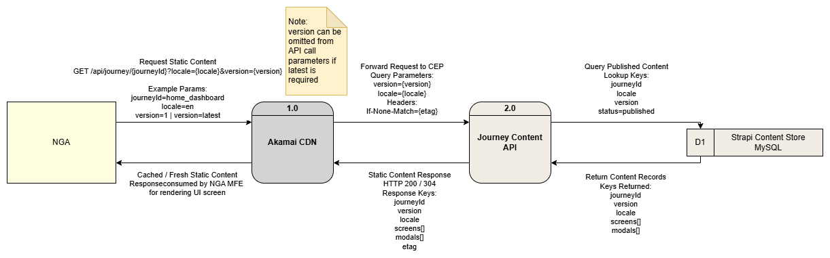

L2
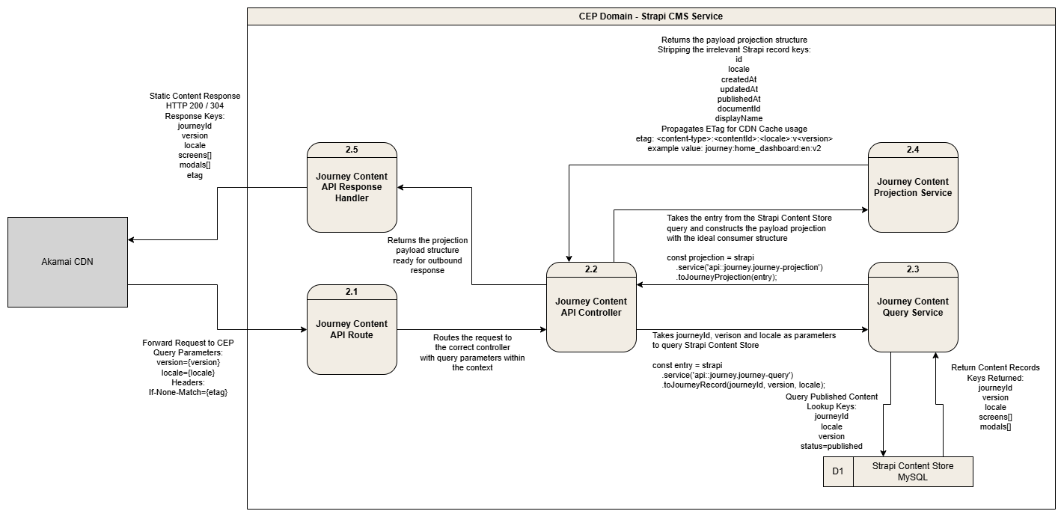

Dynamic Content Data Flow
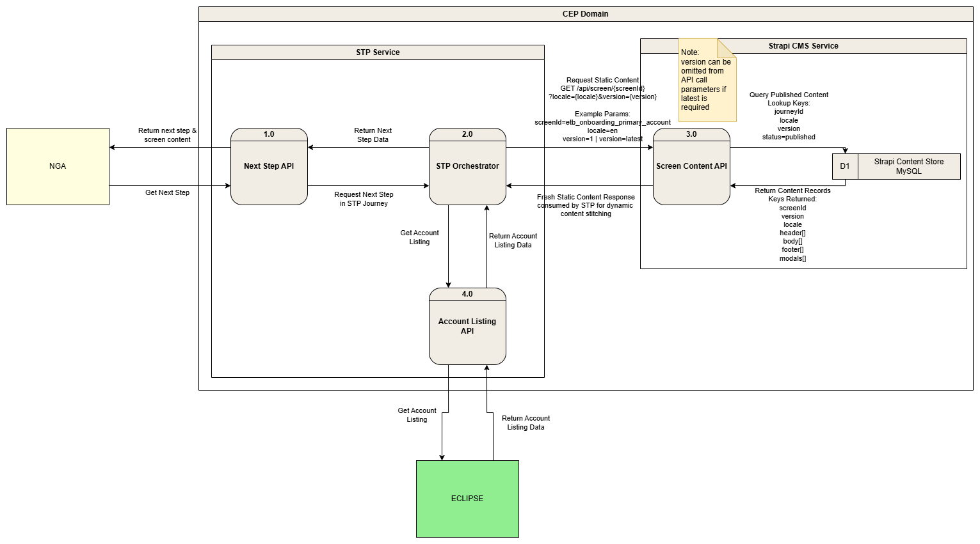

Hybrid Content Data Flow
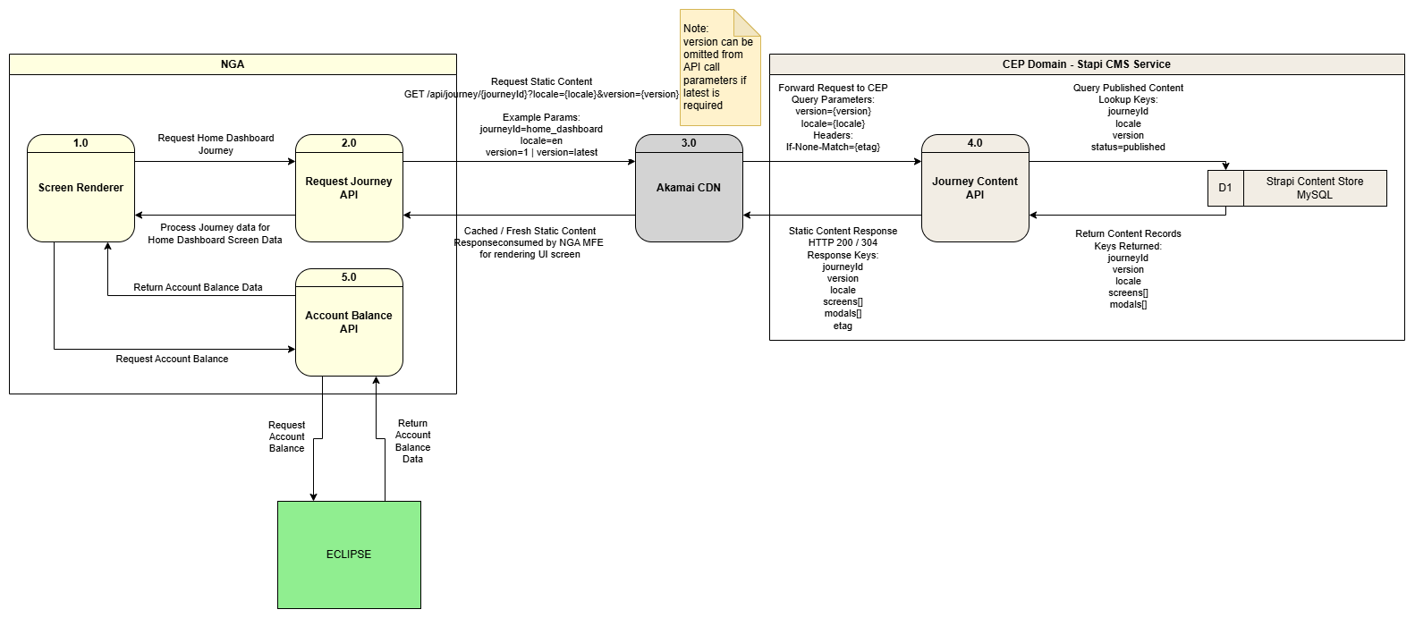

Caching Strategy
Need to add diagrams
The CMS caching strategy is designed to improve content delivery performance, reduce repeated load on Strapi and ensure consumers receive consistent published content. Caching will be applied differently depending on the consuming channel, with frontend-facing requests using CDN-based caching and backend service consumers using internal service-level caching.
Frontend-facing CMS APIs consumed by NGA MFEs will be routed through Akamai CDN. Published content responses should include cache-friendly headers such as ETag and Cache-Control, allowing the mobile application and CDN to determine whether content has changed before downloading the full payload again. The ETag value should be generated based on the content identifier, locale, version and last published timestamp so that changes to published content result in a new cache validator.
Backend services such as STP or MBPNS should call Strapi internally within the CEP domain and should not route through Akamai. These services may maintain their own cache, such as Hazelcast, for frequently accessed CMS content including screen records, journey configurations, notification templates, and receipt templates. Cached records should be stored using stable cache keys based on content type, content ID, locale and version, for example:
- screen:etb_onboard_consent:en:v3
- module:home_dashboard:en:v2
- notification-template:234:en:v5
When content is published or updated in Strapi, a publish webhook should notify the relevant consuming services so that their internal cache can be refreshed or invalidated. This ensures backend services do not continue serving stale content after a new approved version has been published.
The caching approach should follow the principle that Strapi remains the source of truth, while Akamai, application caches and backend service caches act only as delivery optimisation layers. Consumers should always be able to revalidate cached content against the CMS using version, locale and ETag-based checks. Published content should be treated as immutable for a given version, with new content changes resulting in a new versioned record where required.

Appendix

Glossary of Terms
Term | Description
Akamai | CDN platform used to cache and deliver frontend-facing CMS content
API | Application Programming Interface
CDN | Content Delivery Network
CEP | Customer Engagement Platform
CMS | Content Management System
Content Type | A Strapi data model used to define a structured type of content
Collection Type | A Strapi content type that can contain multiple records
Component | A reusable Strapi content structure embedded inside content types
DDD | Detailed Design Document
Dynamic Zone | A Strapi field that allows different component types to be configured flexibly within the same area
ECLIPSE | Enterprise Customer Lifestyle Information Processing Service Engine
ETag | Entity Tag used for cache validation to determine whether content has changed
Hazelcast | Distributed caching platform used by backend services to store frequently accessed CMS content
i18n | Internationalisation; handling multiple languages and locales
ID | Identifier
Locale | Language or regional variation of content, such as en, ms or id
JSON | JavaScript Object Notation
MBPNS | Maybank Platform Notification Suite
MDIP | Maybank Digital Identity Platform
MFE | Micro Frontend
Module | Screens grouped by the NGA Modules (e.g. Settings, Tabung, Money Out etc)
MySQL | Relational database used by Strapi to store CMS records
NGA | NextGen Mobile Application
Payload | Request or response body exchanged through an API
PII | Personally Identifiable Information
P&T | Payment & Transfers (Domain)
QA | Quality Assurance
RBAC | Role-Based Access Control
REST | Representational State Transfer; common API style using HTTP methods such as GET and POST
SLA | Service Level Agreement
SOP | Standard Operating Procedure
SQL | Structured Query Language
STP | Straight-Through-Processing
Strapi | Headless CMS platform used to manage and deliver structured content
UI | User Interface
URL | Uniform Resource Locator
Webhook | Event-based callback triggered by Strapi when content is published or changed

